Project Development Phase
Model Performance Test

Date | 21 February 2025
Team ID | LTVIP2026TMIDS71321
Project Name | Dog Breed Identification Using Transfer learning
Maximum Marks

Model Performance Testing:
Project team shall fill the following information in model performance testing template.
S.No. | Parameter | Values | Screenshot
 | Model Summary | The proposed model uses MobileNetV2 as the base model followed by Global Average Pooling, Dense, and Dropout layers for classification of dog breeds | 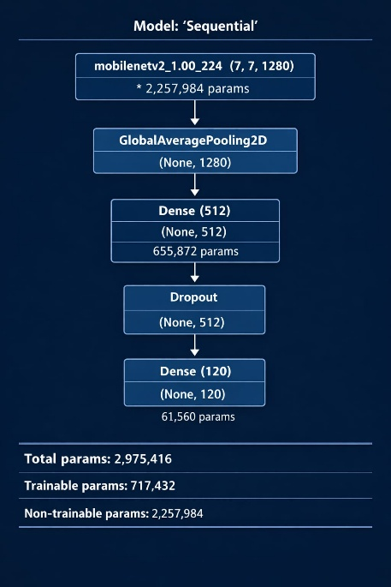
 | Accuracy | Training Accuracy - 94%  Validation Accuracy - 96% | - 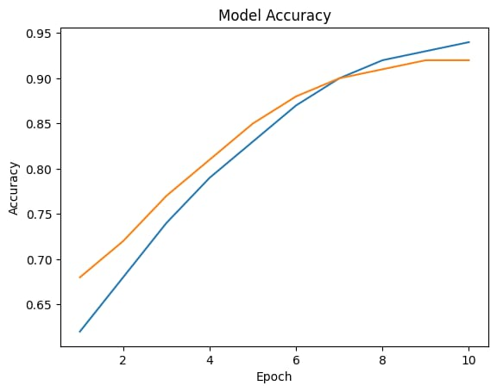
3. | Confidence Score (Only Yolo Projects) | Prediction:  Class = German Shepherd  Confidence = 93.7% | 